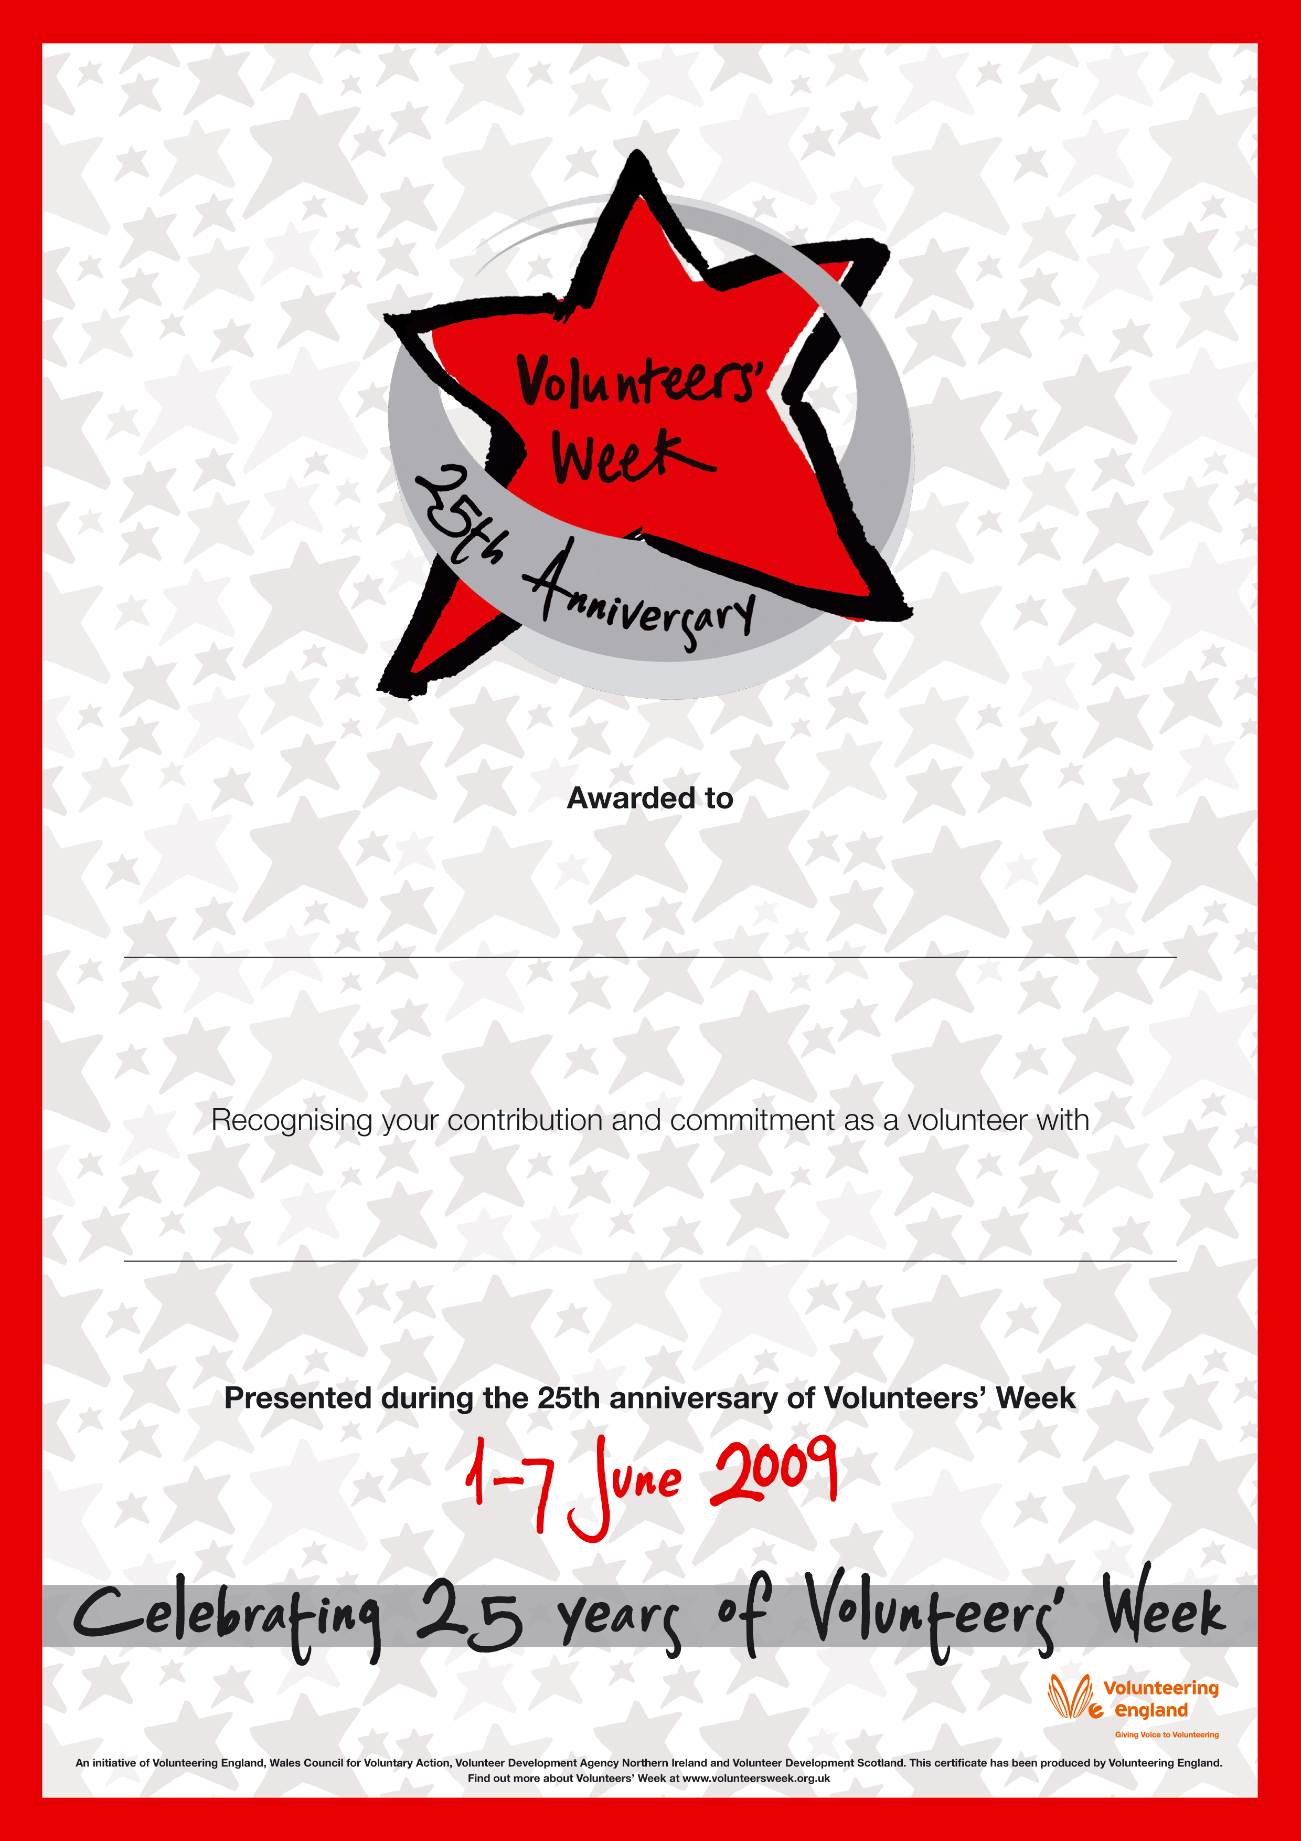
Diane Williams

Unique Care Volunteer

